Custom Upload Form

Complete this form to the best of your ability to get the process started on creating your company’s custom upload portal on the Duncan-Parnell website. It is mandatory to have watched the screencast video online before starting this form. It can be viewed from the following link:
TAB 1: ENTRY TAB
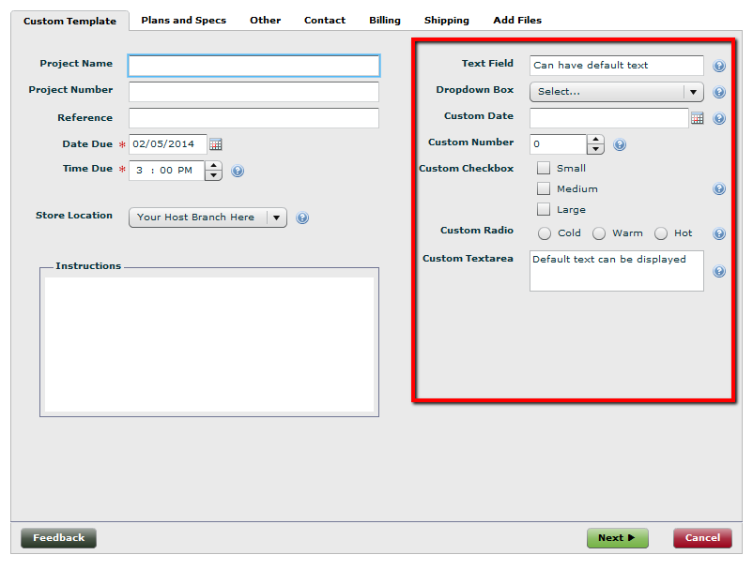

Notes for tab:
This tab is required. The name of the tab will be customized with name of your company. The area on the right side (outlined in red) is where any custom fields can be created using any combination of the types that were described in the screencast you watched. Indicate below what type and if the field is required. In the notes area, indicate any special properties, for instance if a dropdown box, what are the choices that need to be populated within.
CUSTOM FIELDS FOR TAB 1: ENTRY TAB

PROVIDED FIELD NAME VISIBLE REQUIRED
Project Name | required | Choose an item.
Project Number | Choose an item. | Choose an item.
Reference | Choose an item. | Choose an item.
Instructions | Choose an item. | Choose an item.

CUSTOM FIELD NAME TYPE REQUIRED NOTES
Click here to enter text. | Choose an item. | Choose an item. | Click here to enter text.
Click here to enter text. | Choose an item. | Choose an item. | Click here to enter text.
Click here to enter text. | Choose an item. | Choose an item. | Click here to enter text.
Click here to enter text. | Choose an item. | Choose an item. | Click here to enter text.
Click here to enter text. | Choose an item. | Choose an item. | Click here to enter text.
Click here to enter text. | Choose an item. | Choose an item. | Click here to enter text.
Click here to enter text. | Choose an item. | Choose an item. | Click here to enter text.
Click here to enter text. | Choose an item. | Choose an item. | Click here to enter text.
Click here to enter text. | Choose an item. | Choose an item. | Click here to enter text.
Click here to enter text. | Choose an item. | Choose an item. | Click here to enter text.

TAB 2: PLANS/SPECS
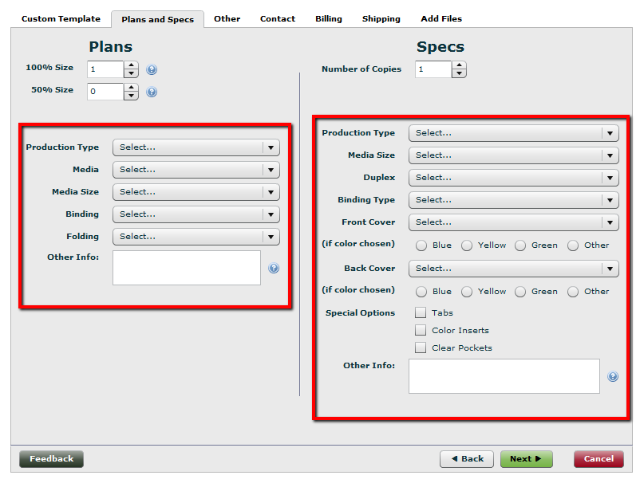

Notes for tab: Choose an item.
This tab is NOT required. If you feel like everything needed to explain uploads can be accomplished from the first tab, we can eliminate this tab completely. Indicate above if you don’t need this tab at all. The areas on the right and left sides (outlined in red) are where any custom fields can be created using any combination of the types that were described in the screencast you watched. Indicate below what type and if the field is required. In the notes area, indicate any special properties, for instance if a dropdown box, what are the choices that need to be populated within.

CUSTOM FIELDS FOR TAB 2: PLANS/SPECS

CUSTOM FIELD NAME (Plans) TYPE REQUIRED NOTES
Click here to enter text. | Choose an item. | Choose an item. | Click here to enter text.
Click here to enter text. | Choose an item. | Choose an item. | Click here to enter text.
Click here to enter text. | Choose an item. | Choose an item. | Click here to enter text.
Click here to enter text. | Choose an item. | Choose an item. | Click here to enter text.
Click here to enter text. | Choose an item. | Choose an item. | Click here to enter text.
Click here to enter text. | Choose an item. | Choose an item. | Click here to enter text.
Click here to enter text. | Choose an item. | Choose an item. | Click here to enter text.
Click here to enter text. | Choose an item. | Choose an item. | Click here to enter text.
Click here to enter text. | Choose an item. | Choose an item. | Click here to enter text.
Click here to enter text. | Choose an item. | Choose an item. | Click here to enter text.

CUSTOM FIELD NAME (Specs) TYPE REQUIRED NOTES
Click here to enter text. | Choose an item. | Choose an item. | Click here to enter text.
Click here to enter text. | Choose an item. | Choose an item. | Click here to enter text.
Click here to enter text. | Choose an item. | Choose an item. | Click here to enter text.
Click here to enter text. | Choose an item. | Choose an item. | Click here to enter text.
Click here to enter text. | Choose an item. | Choose an item. | Click here to enter text.
Click here to enter text. | Choose an item. | Choose an item. | Click here to enter text.
Click here to enter text. | Choose an item. | Choose an item. | Click here to enter text.
Click here to enter text. | Choose an item. | Choose an item. | Click here to enter text.
Click here to enter text. | Choose an item. | Choose an item. | Click here to enter text.
Click here to enter text. | Choose an item. | Choose an item. | Click here to enter text.

TAB 3: OTHER (CUSTOM)
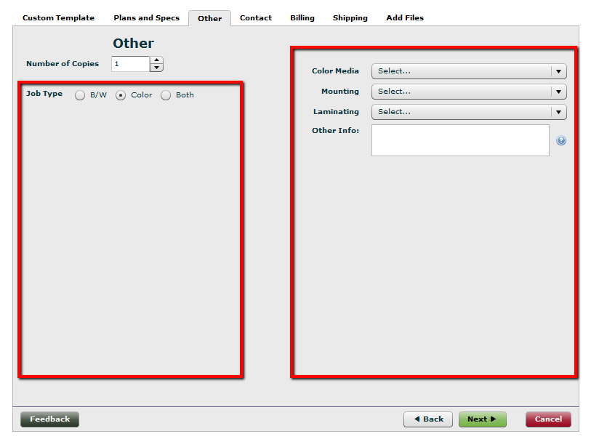

Notes for tab: Choose an item.
This tab is NOT required. This tab can be created to list additional services your company routinely requests, like color printing or scanning services. Indicate above if you don’t need this tab at all. The areas on the right and left sides (outlined in red) are where any custom fields can be created using any combination of the types that were described in the screencast you watched. Indicate below what type and if the field is required. In the notes area, indicate any special properties, for instance if a dropdown box, what are the choices that need to be populated within.

CUSTOM FIELDS FOR TAB 3: OTHER (CUSTOM)

CUSTOM FIELD NAME (Left) TYPE REQUIRED NOTES
Click here to enter text. | Choose an item. | Choose an item. | Click here to enter text.
Click here to enter text. | Choose an item. | Choose an item. | Click here to enter text.
Click here to enter text. | Choose an item. | Choose an item. | Click here to enter text.
Click here to enter text. | Choose an item. | Choose an item. | Click here to enter text.
Click here to enter text. | Choose an item. | Choose an item. | Click here to enter text.
Click here to enter text. | Choose an item. | Choose an item. | Click here to enter text.
Click here to enter text. | Choose an item. | Choose an item. | Click here to enter text.
Click here to enter text. | Choose an item. | Choose an item. | Click here to enter text.
Click here to enter text. | Choose an item. | Choose an item. | Click here to enter text.
Click here to enter text. | Choose an item. | Choose an item. | Click here to enter text.

CUSTOM FIELD NAME (Right) TYPE REQUIRED NOTES
Click here to enter text. | Choose an item. | Choose an item. | Click here to enter text.
Click here to enter text. | Choose an item. | Choose an item. | Click here to enter text.
Click here to enter text. | Choose an item. | Choose an item. | Click here to enter text.
Click here to enter text. | Choose an item. | Choose an item. | Click here to enter text.
Click here to enter text. | Choose an item. | Choose an item. | Click here to enter text.
Click here to enter text. | Choose an item. | Choose an item. | Click here to enter text.
Click here to enter text. | Choose an item. | Choose an item. | Click here to enter text.
Click here to enter text. | Choose an item. | Choose an item. | Click here to enter text.
Click here to enter text. | Choose an item. | Choose an item. | Click here to enter text.
Click here to enter text. | Choose an item. | Choose an item. | Click here to enter text.

TAB 4: CONTACT
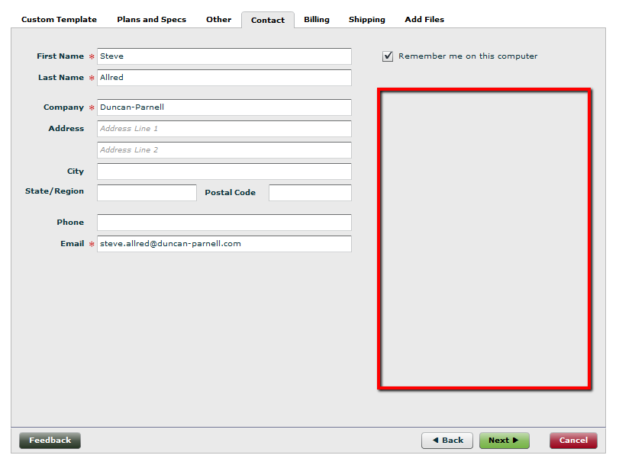

Notes for tab:
This tab is required. The area on the right (outlined in red) is where any custom fields can be created using any combination of the types that were described in the screencast you watched. Indicate below what type and if the field is required. In the notes area, indicate any special properties, for instance if a dropdown box, what are the choices that need to be populated within.

CUSTOM FIELDS FOR TAB 4: CONTACT

PROVIDED FIELD NAME VISIBLE REQUIRED
First Name | required | required
Last Name | required | required
Company | required | Choose an item.
Address | required | Choose an item.
City | required | Choose an item.
State/Region | required | Choose an item.
Postal Code | required | Choose an item.
Phone | required | Choose an item.
Email | required | required

CUSTOM FIELD NAME TYPE REQUIRED NOTES
Click here to enter text. | Choose an item. | Choose an item. | Click here to enter text.
Click here to enter text. | Choose an item. | Choose an item. | Click here to enter text.
Click here to enter text. | Choose an item. | Choose an item. | Click here to enter text.
Click here to enter text. | Choose an item. | Choose an item. | Click here to enter text.
Click here to enter text. | Choose an item. | Choose an item. | Click here to enter text.
Click here to enter text. | Choose an item. | Choose an item. | Click here to enter text.
Click here to enter text. | Choose an item. | Choose an item. | Click here to enter text.
Click here to enter text. | Choose an item. | Choose an item. | Click here to enter text.
Click here to enter text. | Choose an item. | Choose an item. | Click here to enter text.
Click here to enter text. | Choose an item. | Choose an item. | Click here to enter text.

TAB 5: BILLING
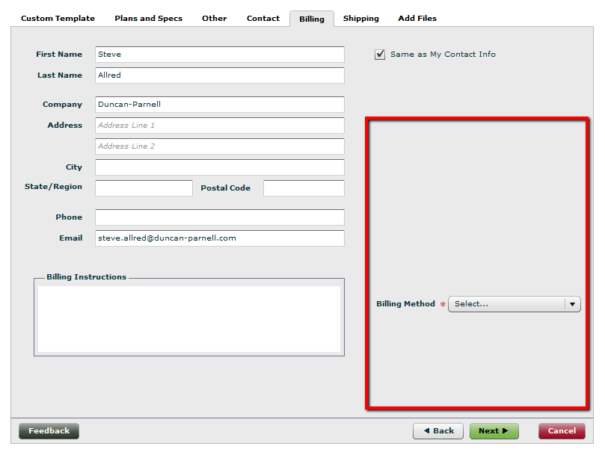

Notes for tab: Choose an item.
This tab is NOT required. Any orders we receive, it will be assumed the billing information is the same as the contact information. The area on the right (outlined in red) is where any custom fields can be created using any combination of the types that were described in the screencast you watched. Indicate below what type and if the field is required. In the notes area, indicate any special properties, for instance if a dropdown box, what are the choices that need to be populated within.

CUSTOM FIELDS FOR TAB 5: BILLING

PROVIDED FIELD NAME VISIBLE REQUIRED
First Name | required | Choose an item.
Last Name | required | Choose an item.
Company | required | Choose an item.
Address | required | Choose an item.
City | required | Choose an item.
State/Region | required | Choose an item.
Postal Code | required | Choose an item.
Phone | required | Choose an item.
Email | required | required
Billing Instructions | required | required
Billing Method | required | required | Click here to enter text.

CUSTOM FIELD NAME TYPE REQUIRED NOTES
Click here to enter text. | Choose an item. | Choose an item. | Click here to enter text.
Click here to enter text. | Choose an item. | Choose an item. | Click here to enter text.
Click here to enter text. | Choose an item. | Choose an item. | Click here to enter text.
Click here to enter text. | Choose an item. | Choose an item. | Click here to enter text.
Click here to enter text. | Choose an item. | Choose an item. | Click here to enter text.
Click here to enter text. | Choose an item. | Choose an item. | Click here to enter text.
Click here to enter text. | Choose an item. | Choose an item. | Click here to enter text.
Click here to enter text. | Choose an item. | Choose an item. | Click here to enter text.
Click here to enter text. | Choose an item. | Choose an item. | Click here to enter text.
Click here to enter text. | Choose an item. | Choose an item. | Click here to enter text.

TAB 6: SHIPPING
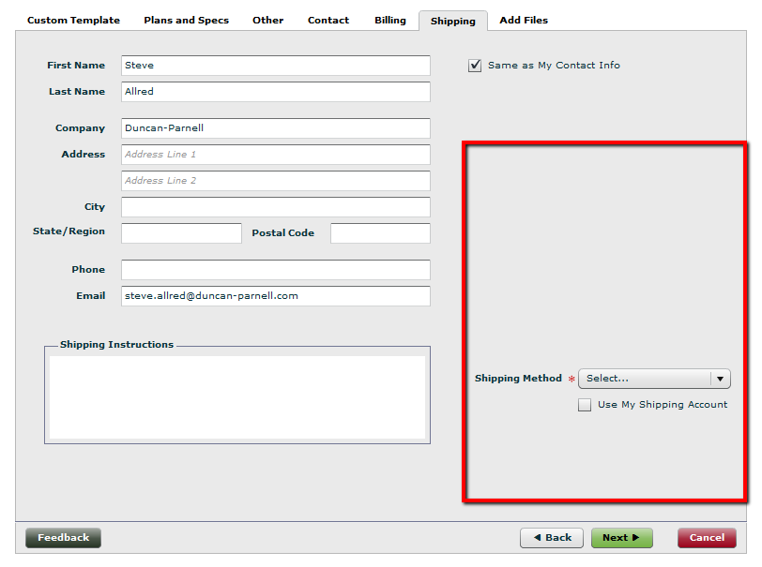

Notes for tab: Choose an item.
This tab is NOT required. Any orders we receive, it will be assumed the shipping information is the same as the contact information. The area on the right (outlined in red) is where any custom fields can be created using any combination of the types that were described in the screencast you watched. Indicate below what type and if the field is required. In the notes area, indicate any special properties, for instance if a dropdown box, what are the choices that need to be populated within.

CUSTOM FIELDS FOR TAB 6: SHIPPING

PROVIDED FIELD NAME VISIBLE REQUIRED
First Name | required | Choose an item.
Last Name | required | Choose an item.
Company | required | Choose an item.
Address | required | Choose an item.
City | required | Choose an item.
State/Region | required | Choose an item.
Postal Code | required | Choose an item.
Phone | required | Choose an item.
Email | required | required
Shipping Instructions | required | required
Shipping Method | required | required | Click here to enter text.

CUSTOM FIELD NAME TYPE REQUIRED NOTES
Click here to enter text. | Choose an item. | Choose an item. | Click here to enter text.
Click here to enter text. | Choose an item. | Choose an item. | Click here to enter text.
Click here to enter text. | Choose an item. | Choose an item. | Click here to enter text.
Click here to enter text. | Choose an item. | Choose an item. | Click here to enter text.
Click here to enter text. | Choose an item. | Choose an item. | Click here to enter text.
Click here to enter text. | Choose an item. | Choose an item. | Click here to enter text.
Click here to enter text. | Choose an item. | Choose an item. | Click here to enter text.
Click here to enter text. | Choose an item. | Choose an item. | Click here to enter text.
Click here to enter text. | Choose an item. | Choose an item. | Click here to enter text.
Click here to enter text. | Choose an item. | Choose an item. | Click here to enter text.

